Name: Kurt Glock
E-mail: kurt.glock@boku.ac.at
Institution: University of Natural Resources and Life Sciences, Vienna
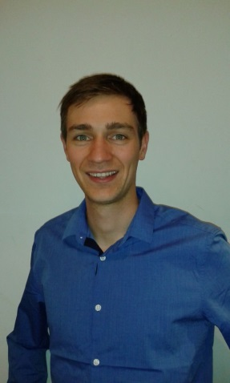 | DI Glock graduated from BOKU as Enviromental Engineer and has been working since 2013 as a project engineer in Dr. Tritthart’s computational river modelling group at BOKU. Since 2016 he is enroled in the doctoral studies of natural resources and life sciences at BOKU. The focus of his work is planning and evaluation of river engineering measures based on numerical simulations considering issues of sediment transport and ecology.  Within the SWARM project he is a team member of BOKU responsible for technical and financial reporting. Under the lead of Dr. Tritthart he is focusing on WP1 and supports the project partners in the remaining WPs.
References (max. 5 relevant references)
1. Glas, M., Glock, K., Tritthart, M., Liedermann, M., Habersack, H. 2018. Hydrodynamic and morphodynamic sensitivity of a river’s main channel to groyne geometry. Journal of Hydraulic Research, 56 (5), 714-726, 10.1080/00221686.2017.1405369.
2. Glock, K., Tritthart, M., Rindler, R., Liedermann, M., Habersack, H. 2018. Numerical investigation of bedload transport processes during flood events at the Drau River. Proceedings of the 5th IAHR Europe Congress, Trento, Italy.
3. Glock, K., Tritthart, M., Gmeiner, P., Pessenlehner, S., Habersack, H. 2017. Evaluation of engineering measures on the Danube based on numerical analysis. Journal of Applied Water Engineering and Research, 1-19, 10.1080/23249676.2017.1355757.

This project has been funded with support from the European Commission. This publication reflects the views only of the author, and the Commission cannot be held responsible for any use which may be made of the information contained therein.

